Media release, 4 July 2022

Media corner at www.swissdeluxehotels.com/en/media

Swiss Deluxe Hotels stronger after pandemic and ready for business to boom

Number of overnight stays increases by 42.4% to reach a total of 1,038,335 nights

2022 is looking brighter

Swiss market grows by 45.6% and hits a new record of over half a million overnight stays (market share of 53.2%)

Staff shortages pose the biggest challenge

Michael Smithuis, President of Swiss Deluxe Hotels:
“Based on the current bookings, Swiss Deluxe Hotels is optimistic about the summer season ahead. We’re absolutely delighted to finally be welcoming international guests back to our hotels.”

Zurich, 4 July 2022 – Swiss Deluxe Hotels – the association of 39 of the most exclusive 5-star hotels in Switzerland – saw the number of overnight stays, the occupancy rate and the sales figures start to rise again in 2021. Several markets have recovered after the disruption caused by the pandemic during the year before that. While the number of Swiss guests has actually reached an all-time high, some markets in Asia still need time to recover. At its Annual General Meeting in St. Moritz on 1 July 2022, Swiss Deluxe Hotels was full of optimism for the rest of the year ahead and identified a shortage of qualified staff as one of the biggest challenges to be faced.

Members of Swiss Deluxe Hotels met at “Badrutt’s Palace Hotel” in St. Moritz for the Annual General Meeting on 1 July 2022. The 39 Swiss Deluxe Hotels approved the statutory business for 2021 and shared their optimism for the rest of this year and further into the future. During 2021, the Swiss Deluxe Hotels clocked up a total of 1,038,335 overnight stays between them, which equates to year-on-year growth of 42.4%. The hotel industry in Switzerland on the whole has recovered at a slightly slower pace, recording 24.6% growth within the same period. By way of comparison, growth among all of the 90 or so 5-star hotels in Switzerland stood at 34.5%. The total turnover of the 39 Swiss Deluxe Hotels (and all their affiliated businesses) increased by 20.9% to around CHF 1.38 billion. That brings them up to around 80% of the pre-pandemic level.

Record high for the Swiss domestic market
The global travel restrictions brought about further growth on the internal market in 2021. The Swiss Deluxe Hotels have never recorded as many Swiss guests staying overnight in any single year as they did in 2021. With the figure sitting at 552,187 nights, the domestic market accounted for a 53.2% market share last year.

Looking at the figures for guests coming from other countries, there were two sides to the story. Significantly more guests made their way from neighbouring European countries like Germany (+48.0%) and France (+26.9%) and the Gulf Region was back in third place in the list of countries guests came from thanks to growth hitting 162.8%. Meanwhile, the number of guests visiting from Asian countries remained very low. It can be assumed that China and other countries in Asia will need another two or three years to recover fully. As one of the core markets prioritised by Swiss Deluxe Hotels, the United States developed positively, with growth of around 130% despite some travel restrictions remaining in place.

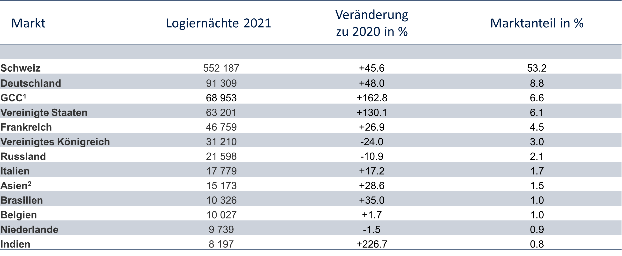

¹ United Arab Emirates, Saudi Arabia, Qatar, Kuwait, Bahrain and Oman
² Japan, Taiwan, Hong Kong, Thailand, Singapore, Indonesia, Korea, Malaysia, Philippines, the remainder of South, East and West Asia

Bright future
The 2021/2022 winter season started the year off well for the Swiss Deluxe Hotels resort destinations. With coronavirus restrictions having eased even further, the sun is shining down on the summer season ahead. Even the city hotels are expecting occupancy rates to jump up now that social and business events are filling our diaries once more. It goes without saying that the geopolitical tension in Ukraine brings with it a certain level of uncertainty and the potential to offset a boom in business.

Staff shortage
The 39 members of Swiss Deluxe Hotels are ready and raring to go. Many of the hotels made the most of the quieter periods and the time spent in lockdown by renovating and optimising their establishments. But one of the biggest challenges will continue to be the shortage of staff with the right qualifications and training. The phase of reduced workforces, furlough and redundancies has brought about a change in the workforce. “Now it’s over to us to show off just how attractive all the different careers in the world of luxury hotels are. To make that happen, we’re hoping to work more closely with the specialist hotel schools we’re lucky enough to have here in Switzerland,” says Michael Smithuis, President of Swiss Deluxe Hotels and General Manager of the Fairmont Le Montreux Palace in Montreux.

Summer issue of «H» Magazine
Under the title “Lake Geneva – where summer is easy”, the theme for this year’s summer issue of the Swiss Deluxe Hotels magazine is the lake and its surrounding area. A firm favourite with important figures in world history and culture, this globally revered riviera covers the area from Montreux to Geneva with Vevey and Lausanne in between. 50,000 copies of the magazine will be printed to start with. They will make their way to all 39 Swiss Deluxe Hotels, lots of airport lounges for first-class and business-class passengers, all of Audi’s showrooms in Switzerland and the information desks at all Globus department stores.

Swiss Deluxe Hotels

Originally founded in 1934, the Swiss Deluxe Hotels (SDH) association is made up of 39 of the most prestigious 5-star hotels across Switzerland, including “The Dolder Grand” and the “Baur au Lac” in Zurich, the “Victoria-Jungfrau Grand Hotel & Spa” in Interlaken, the “Gstaad Palace” and the “Beau-Rivage Palace” in Lausanne, the “Badrutt’s Palace Hotel” and the “Kulm Hotel” in St. Moritz, the “Castello del Sole” in Ascona and the “Grand Hotel Les Trois Rois” in Basel. They’re all prime examples of the prestige of the Swiss luxury hotel business, which they’ve played their part in maintaining over the course of almost two centuries. With 4,100 rooms and suites and around 8,200 beds in total, Swiss Deluxe Hotels represents 40% of the 5-star capacity available in Switzerland. That makes SDH the biggest and most influential association within this particular sector. No wonder it’s been playing such a leading role on the Swiss luxury hotel stage for decades. The name “Swiss Deluxe Hotels” has come to be associated with exclusive luxury and the highest of standards. The service is simply exquisite. Over 5,000 members of staff work their magic to cater to a discerning clientele accustomed to high-end service. In 2021, the Group recorded around 1,038,335 overnight stays and an annual turnover of around CHF 1.38 billion.

Figures are sometimes based on projections for all 39 Swiss Deluxe Hotels as a group in 2021.

Please don’t hesitate to get in touch if you’d like more information:

Evelyn Gorgos
Head of Corporate Communications and Media Relations
Swiss Deluxe Hotels
Augustinergasse 30, 8001 Zurich
gorgos@swissdeluxehotels.com
Tel. +41 (0)43 243 71 40
Mobile +41 (0)78 677 93 07

